# Analysis of Funding Rate vs. Award Amount Received by College/Division

The attached pivot tables summarize the proposal and award activity from Q1FY24 to Q3FY25. While reviewing the data, it is evident that some Colleges/Divisions (e.g., Business, Arts & Sciences, Education) show a relatively high Funding Rate (%), yet their share of the total dollar amount received is minimal. Dr. Parag requested an explanation for this pattern.

## Interpretation of Discrepancies in Funding Rate vs. Award Amount

A high funding rate indicates that a large proportion of submitted proposals have been awarded. However, this metric does not account for the size or monetary value of those awards. For instance:

- The College of Business has an 88.46% funding rate, but only 0.77% of the total award dollars. This suggests that while most of their proposals are successful, the award amounts are relatively small.  
- Similarly, Education shows a 42.11% funding rate, but only 0.43% of the total amount received.

The second and third pivot tables help provide context by breaking down the number of grants and the total award dollars by sponsor type. From these tables:

- Business College has a high percentage (26.09%) of its grants from Business sponsors, who generally award smaller grants.  
- Their funding is also diversified with 13.04% from Federal sponsors and 30.43% from Non-profits, which are often lower-value grants.  
- The funding amount confirms this pattern, with only 6.97% from Business sponsors and 54.09% from State sponsors, suggesting a limited pool of high-dollar federal funding.

Therefore, high funding rates in certain divisions reflect strong proposal success in quantity but not necessarily in dollar value. This distinction is essential when interpreting productivity or impact based on funding metrics.

## Attached Data Visuals

Figure 1: Q1FY24–Q3FY25 Proposal and Award Summary

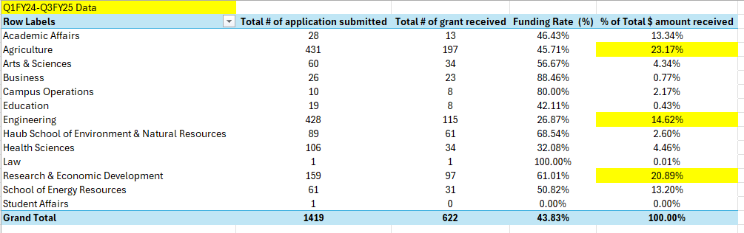

Figure 2: Breakdown of Award Counts and Amounts by Sponsor Type

